Question 1 PART A: A random variable X is uniformly distributed over the interval [−0.5 , 0.5]. Given that a sample of n = 64 values is taken, determine the probability that the total sum of these values exceeds 4. Use the Central Limit Theorem (CLT) to approximate the probability. Refer to the following properties of a continuous uniform random variable:
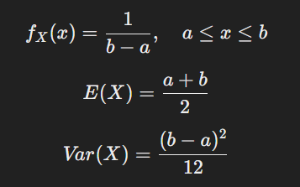
Use these formulas to calculate the mean and variance of the sum of 64 independent uniform random variables and apply CLT to find the required probability.
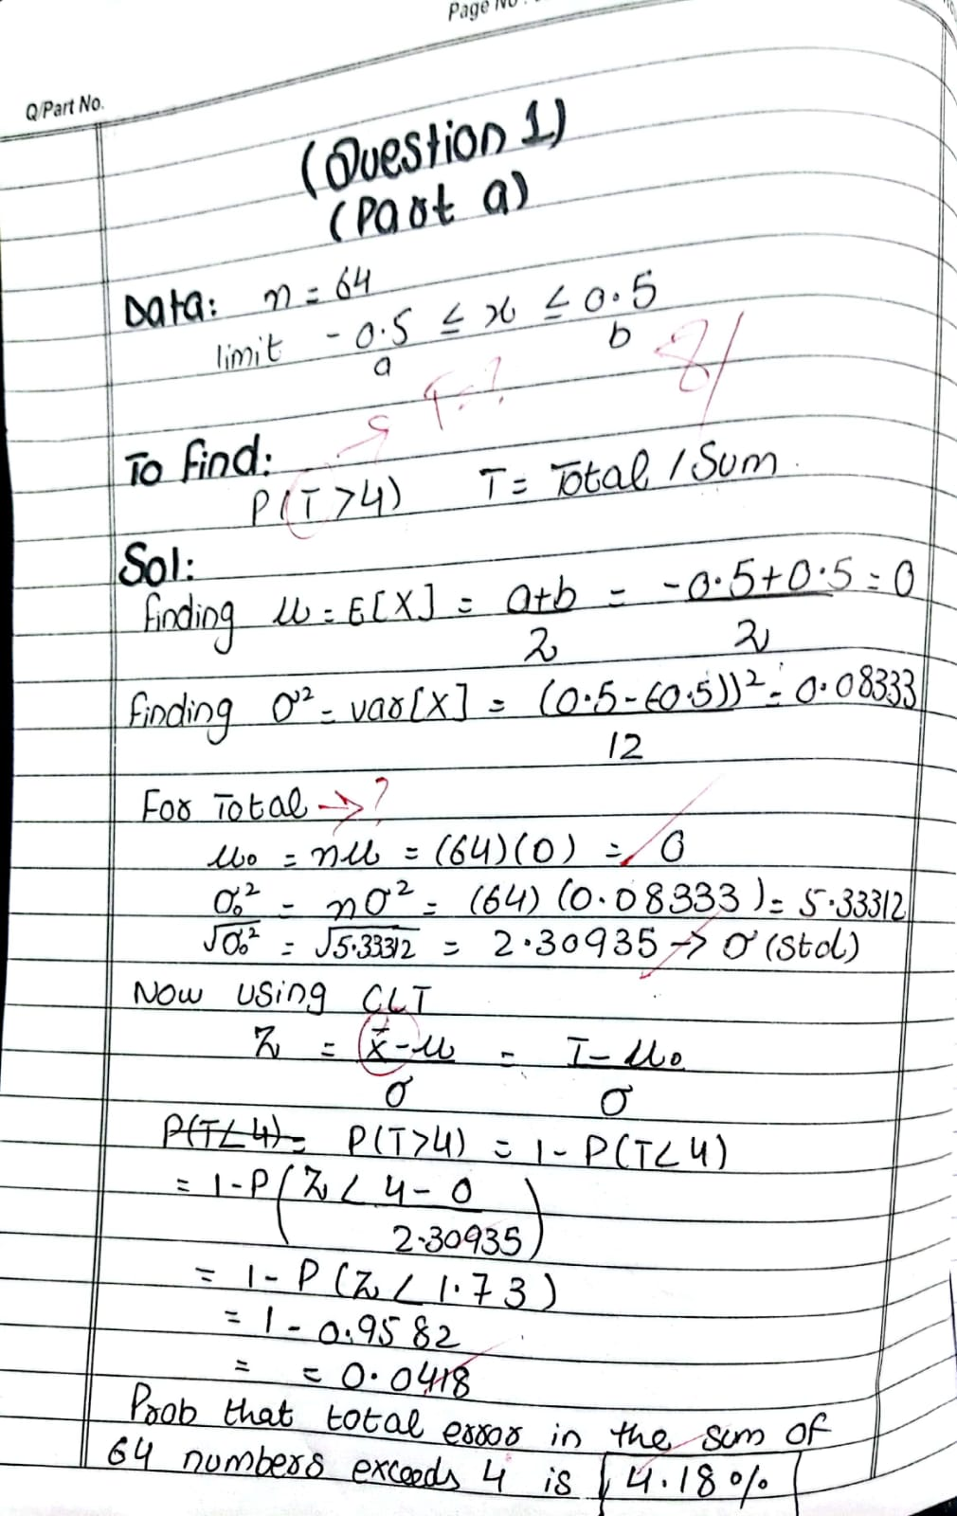

Question 1 PART B: The population of a certain variable has a true mean μ=10 and a true variance σ2=4. A random sample of size n = 9 is taken from this population. Using the Central Limit Theorem (CLT), determine the probability that the sample mean Xˉ exceeds 11.

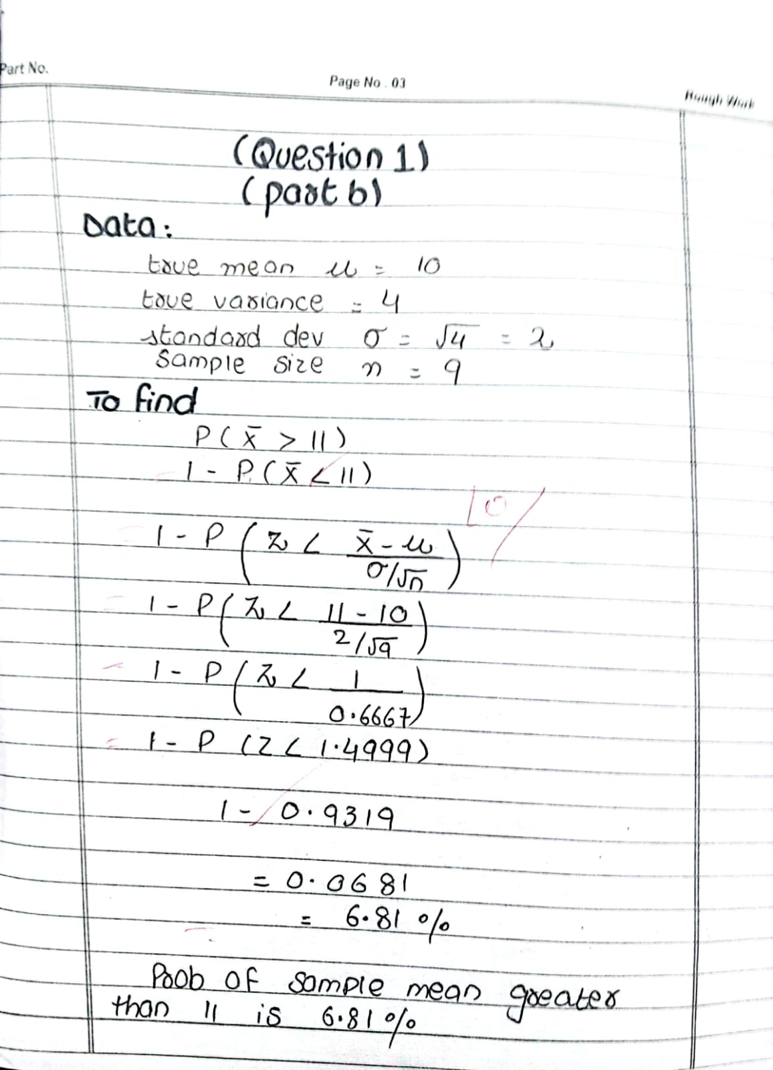

Question 2 PART A:
A random sample of size n=75 is taken from a population with a standard deviation σ=0.0015. The sample mean is found to be Xˉ=0.310. Using a 95% confidence level, construct the confidence interval for the population mean.

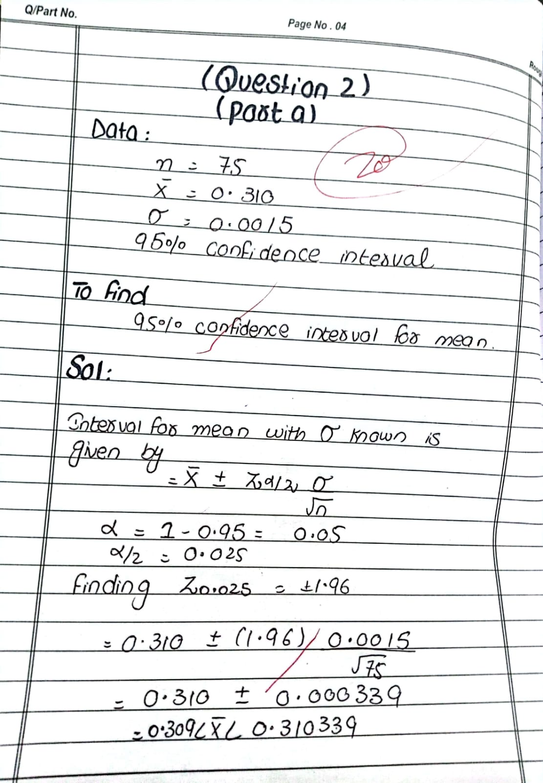

Question 2 PART B:
A researcher wants to estimate the population mean with a 95% confidence level and a margin of error (E) of 0.0005. The population standard deviation is known to be σ=0.0015. Determine the minimum required sample size.
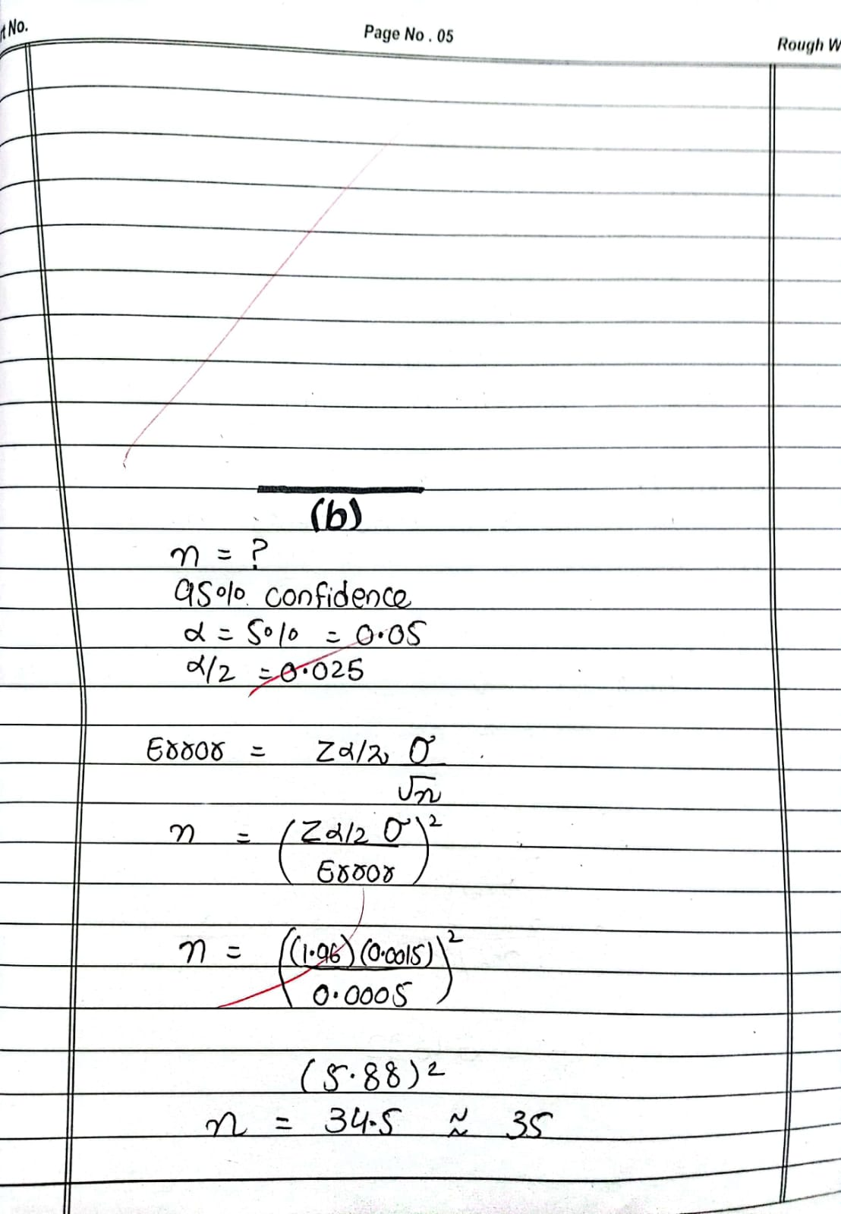

Question 3:
A manufacturing machine is designed to produce parts with a mean thickness of 2 mm. A sample of 10 parts is taken, and their mean thickness is found to be 2.2 mm with a sample variance of 0.04 mm². Conduct a hypothesis test at a 0.05 significance level to determine whether the machine is operating correctly.

